(Under Construction)

Retaliation Guide

Video guide can be found here:

Last Updated : Y - M - D

Retaliation

Body

Agitation

Body

Gamemode

Body

Kill Squads

Body

Targeted Loot

Body

Recources

Body

Exotic Blueprints
Hyena | OutCasts | True Sons | Cleaners | Rikers
Kill Squads Rewards | Kill Squads Rewards | Kill Squads Rewards | Kill Squads Rewards | Kill Squads Rewards
Crystallized Spice  Hyenas Tac. Ass. | Biohazardous Canisters  Outcast Tac. Ass. | Military Dogtags  True Sons Tac. Ass. | Burning Ash  Cleaners Tac. Ass. | Crossed Balaclava  Rikers Tac. Ass.
  Centurion’s Scabbard | 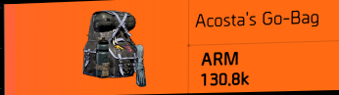  Acosta’s Go-Bag | 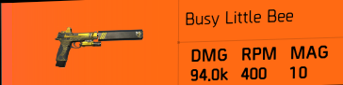  Busy Little Bee | 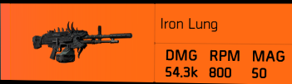  Iron Lung |   Bloody Knuckles
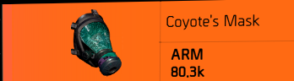  Coyote’s Mask | 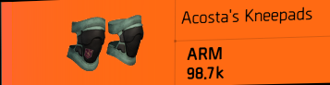  Acosta’s Kneepads |   Catharsis | 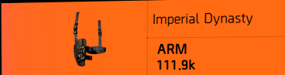  Imperial Dynasty | 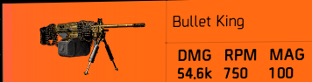  Bullet King
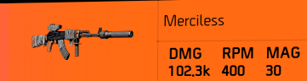  Merciless | 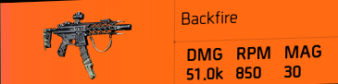  Backfire | 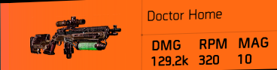  Doctor Home | 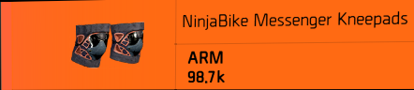  Ninjabike Messenger Kneepads | 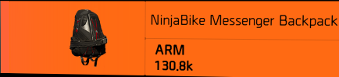  Ninjabike Messenger Backpack
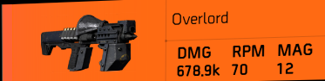  Overlord | 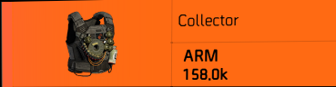  Collector | 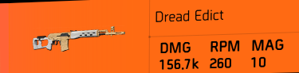  Dread Edict
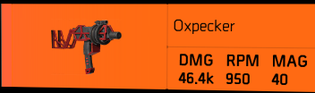  Oxpecker | 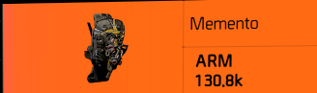  Memento | 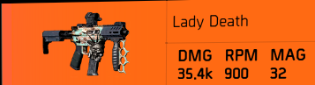  Lady Death
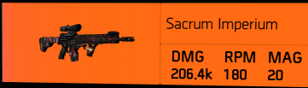  Sacrum Imperium | 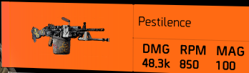  Pestilence | 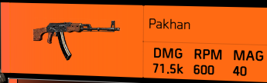  Pakhan
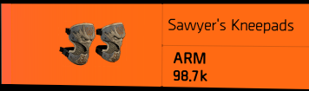  Sawyer’s Kneepads | 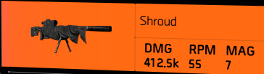  Shroud | 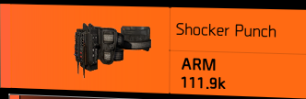  Shocker Punch
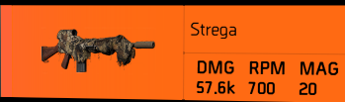  Strega | 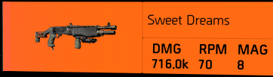  Sweet Dreams | 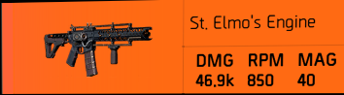  St. Elmo’s Engine
Completion Rewards | Completion Rewards | Completion Rewards | Completion Rewards | Completion Rewards
Automated Defence Parts  Black Tusk Tac. Ass. | Automated Defence Parts  Black Tusk Tac. Ass. | Automated Defence Parts  Black Tusk Tac. Ass.
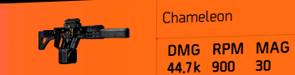Chameleon | 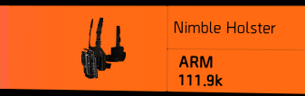  Nimble Holster | 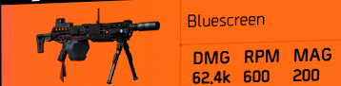  Bluescreen
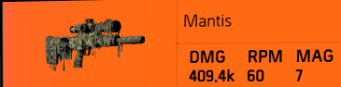  Mantis | 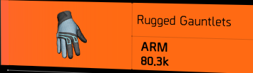  Rugged Gauntlets |   BTSU Datagloves
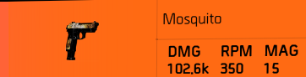  Mosquito | 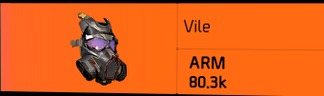  Vile | 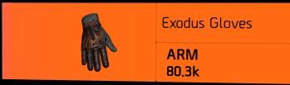  Exodus Gloves
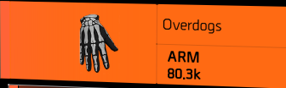  Overdogs | 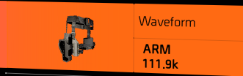  Waveform | 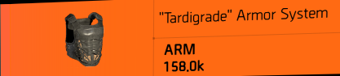  “Tardigrade” Armor System
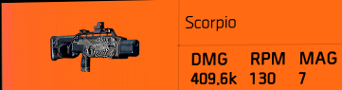
Scorpio

Unavailable Exotics
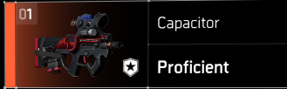  Capacitor  Summit 5 challenges reward | 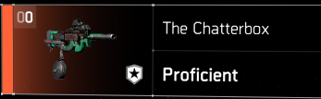  The Chatterbox  Hyena lockbox crafting blueprint and parts | 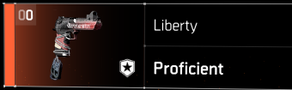  Liberty  True Sons mission bosses crafting blueprint and parts | 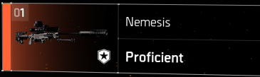  Nemesis  Invaded mission crafting blueprint and parts
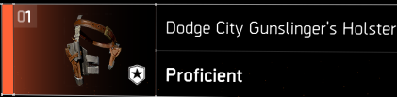  Dodge City Gunslinger’s Holster  Project crafting blueprint and parts | 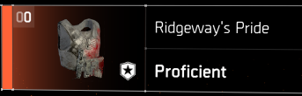  Ridgeway’s Pride  Summit parts leading to project for blueprint
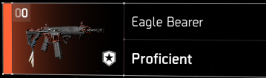  Eagle Bearer  Raid/DZ item, sometimes available with events | 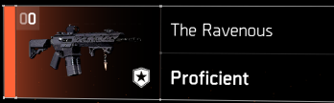  The Ravenous  Raid/DZ item, sometimes available with events | 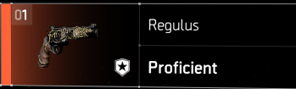  Regulus  Raid/DZ item, sometimes available with events | 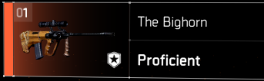  The Big Horn  Legendary/DZ item, sometimes available with events | 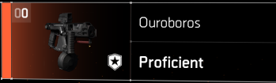  Orouboros  Incursion/DZ item, sometimes available with events
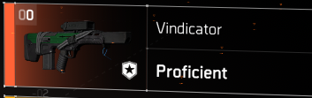  Vindicator  Descent item buyable with NSA tech currency | 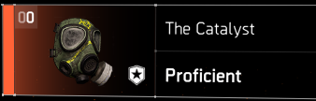  The Catalyst  Brooklyn DLC item, Charlie named boss and army terminal |  | 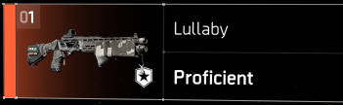  Lullaby  Stats from Sweet Dreams, only differs in looks | 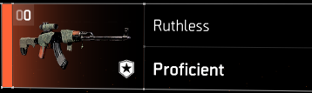  Ruthless  Stats from Merciless, only differs in looks
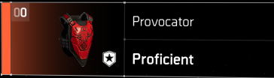  Provocator  Y6S2 Climax mission reward | 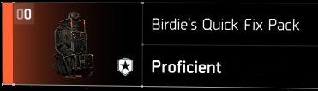  Birdie’s Quick Fix Pack  Y6S3 Climax mission reward | 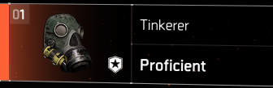  Tinkerer  Y7S1 Climax mission reward | 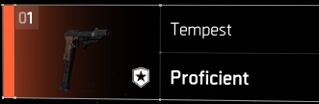  Tempest  Y7S2 Climax mission reward | 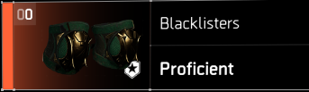  Blacklisters  Y7S2 Climax mission reward
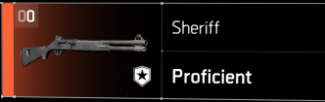
Sheriff
Y7S3 Climax mission reward
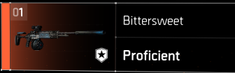  BitterSweet  Current season track item | 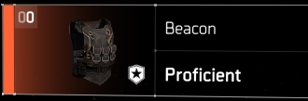  Beacon  Current season track item

Recommended Builds

Body

General Tips

Body

Header

Body

Header

Body

Links to my other guides, the Build Collection, DMG/DPS Calculators and many other things:

https://docs.google.com/document/d/15mg-_sjowh5_8bUp2VIBqnDxCDqz-xJOISl0DlG3RDU

